**SECTION A-46 MARKS**

**Attempt** all **questions in this section.**

1. A solution containing **1.5%** of a polymer was found to have an osmotic pressure of **3.6 x 10-4** atmospheres at room temperature. Calculate the molecular mass of the polymer. (02½ marks)

………………………………………………………………………………………………………………………………………………………………………………………………………………………………………………………………………………………………………………………………………………………………………………………………………………………………………………………………………………………………………………………………………………………………………………………………………………………………………………………………………………………………………………………………………………………………………………………………………………………………………………………………………………………………………………………………………………………………………………………………………………………………………..

1. Explain why in the determination of molecular mass of polymers, osmotic pressure is used instead of ebullioscopic and cryoscopic methods. (02 marks)

………………………………………………………………………………………………………………………………………………………………………………………………………………………………………………………………………………………………………………………………………………………………………………………………………………………………………………………………………………………………………………………………………………………………………………………………………………………………………………………………………………………………………………………………………………………………………………………………………………………………………………………………………………………………………………………………………………………………………………………………………………………………………..

1. Name one reagent that can be used to distinguish between each of the following pairs of compounds. In each case, state what is observed if the reagent is separately treated with each member of the pair.
2. CH3CH2CH2CH(OH)CH3 & CH3CH2CH(OH)CH2CH3 (03 marks)

Reagent: ……………………………………………………………………………………………………………………………………………………………………………………………………………………………………………..

Observation (s): ………………………………………………………………………………………………………………………………………………………………………………………………………………………………………………………………………………………………………………………………………………………………………

1. 2-phenyl-2-methylethan-2-ol & 3-phenylpropan-1-ol (03 marks)

Reagent: ……………………………………………………………………………………………………………………………………………………………………………………………………………………………………………..

Observation (s): ………………………………………………………………………………………………………………………………………………………………………………………………………………………………………………………………………………………………………………………………………………………………………

1. Thorium, ${}_{90}^{232}{Th}$ undergoes radioactive decay to give element, **X** according to the following equation below:

${}_{90}^{232}{Th }$ X + 𝛂

Calculate:

1. The atomic number of element, X. (01 mark)

…………………………………………………………………………………………………………………

1. The mass number of element, X. (01 mark)

…………………………………………………………………………………………………………………

1. Element, X decays further to form element, Y as shown below in the equation:

X Y + 𝛃

Calculate:

1. The atomic number of element, Y. (01 mark)

………………………………………………………………………………………………………………....

1. The mass number of element, Y. (01 mark)

…………………………………………………………………………………………………………………

1. A radioactive isotope of element, X had an initial activity of **250** **counts per second** on a Geiger counter. After **40 minutes**, the activity had declined to **240** **counts per second**. Calculate the **half-life** of element, X. (03 marks)

……………………………………………………………………………………………………………………………………………………………………………………………………………………………………………………………………………………………………………………………………………………………………………………………………………………………………………………………………………………………………………………………………………………………………………………………………………………………………………………………………………………………………………………………………………………………………………………………………………………………………………………………………………………………………………………………………………………………………………………………………………………………………………………………………………………………………………………..

1. Define the term hydration energy. (01 mark)

………………………………………………………………………………………………………………………………………………………………………………………………………………………………………………………………………………………………………………………………………………………………………

1. State two factors which affect the magnitude of hydration energy. (03 marks)

………………………………………………………………………………………………………………………………………………………………………………………………………………………………………………

1. The table below shows enthalpies of hydration of Ca2+ & Cl- ions.

|  |  |
| --- | --- |
| Ions | Enthalpy of hydration [kJ/mol |
| Ca2+ | 1,577 |
| Cl- | 381 |

1. State whether the values of enthalpies of hydration of Ca2+ & Cl- given in the table above are positive or negative. Give a reason for your answer. (01½ marks)

……………………………………………………………………………………………………………………………………………………………………………………………………………………………………………………………………………………………………………………………………………………………………………………………………………………………………………………………………………………………..

1. Calculate the enthalpy of hydration of calcium chloride. (01½ marks)

……………………………………………………………………………………………………………………………………………………………………………………………………………………………………………………………………………………………………………………………………………………………………………………………………………………………………………………………………………………………..

1. The table below shows the first ionization energies and melting points of some group (II) elements of the periodic table. Use the information in it to answer the followings questions.

|  |  |  |  |  |
| --- | --- | --- | --- | --- |
| Elements | Mg | Ca | Sr | Ba |
| 1st Ionization energy [kJ/mol] | 738 | 590 | 549 | 505 |
| Melting points [ᵒC] | 649 | 839 | 769 | 729 |

Briefly explain the variation in trends of:

1. First ionization energy. (02½ marks)

……………………………………………………………………………………………………………………………………………………………………………………………………………………………………………………………………………………………………………………………………………………………………………………………………………………………………………………………………………………………………………………………………………………………………………………………………………………………………………………………………………………………………………………………………………………………………………………………………………………………………………………………………………………………………………………………………………………………………………………………………………………………………………………………………………………………………………………..

1. Melting points. (02½ marks) ……………………………………………………………………………………………………………………………………………………………………………………………………………………………………………………………………………………………………………………………………………………………………………………………………………………………………………………………………………………………………………………………………………………………………………………………………………………………………………………………………………………………………………………………………………………………………………………………………………………………………………………………………………………………………………………………………………………………………………………………………………………………………………………………………………………………………………………..
2. Complete the following equations and write a mechanism for the reaction in each case.
3. CH3CH2Cl + OH- ………………………………………….. (02 marks)

………………………………………………………………………………………………………………………………………………………………………………………………………………………………………………………………………………………………………………………………………………………………………………………………………………………………………………………………………………………………………………………………………………………………………………………………………………………………………………………………………………………………………………………………………………

1. (CH3)3C-Br …………………………………………. (03 marks)

………………………………………………………………………………………………………………………………………………………………………………………………………………………………………………………………………………………………………………………………………………………………………………………………………………………………………………………………………………………………………………………………………………………………………………………………………………………………………………………………………………………………………………………………………………………………………………………………………………………………………………………………………

1. State what would be observed and write equation for the reaction that would take place when:
2. Potassium iodide was added to acidified potassium dichromate solution. (02½ marks)

Observation (s):

………………………………………………………………………………………………………………………………………………………………………………………………………………………………………………

Equation:

………………………………………………………………………………………………………………………………………………………………………………………………………………………………………………

1. Sodium thiosulphate was added to the mixture in a (i) above. (02½ marks)

Observation (s):

………………………………………………………………………………………………………………………………………………………………………………………………………………………………………………

Equation:

………………………………………………………………………………………………………………………………………………………………………………………………………………………………………………

1. Name the reagent(s) and condition(s) that can be used to effect the following changes.
2.  (01 mark)

Reagent (s):

………………………………………………………………………………………………………………………………………………………………………………………………………………………………………………

Observation (s):

………………………………………………………………………………………………………………………………………………………………………………………………………………………………………………

1.  (01 mark)

Reagent (s):

………………………………………………………………………………………………………………………………………………………………………………………………………………………………………………

Observation (s):

………………………………………………………………………………………………………………………………………………………………………………………………………………………………………………

1.  (01 mark)

Reagent (s):

………………………………………………………………………………………………………………………………………………………………………………………………………………………………………………

Observation (s):

………………………………………………………………………………………………………………………………………………………………………………………………………………………………………………

1. Draw the structures and name the shape of the following oxides. In each case state the oxidation state of sulphur atom. (03 marks)

|  |  |  |  |
| --- | --- | --- | --- |
| Oxide (s) | Structure | Shape | Oxidation state of sulphur |
| SO2 |  |  |  |
| SO3 |  |  |  |

1. (i) Name the reagent that can be used to distinguish the oxides in (a). (01 mark)

……………………………………………………………………………………………………………………………………………………………………………………………………………………………………

1. State what would be observed if each oxide is separately treated with the reagent you have named in b (i) above. (01 mark)

…………………………………………………………………………………………………………………………………………………………………………………………………………………………………………………………………………………………………………………………………………………………………………………………………………………………………………………………………………

1. Write equation(s) for the reaction(s) that would take place when each oxide is separately treated with reagent you have named b (i). (01½ marks)

………………………………………………………………………………………………………………………………………………………………………………………………………………………………………………………………………………………………………………………………………………………

**SECTION B-54 MARKS**

**Attempt** ANY **SIX questions in this section.**

1. Write an equation of reaction between water and the oxides of: (@01½ marks)
2. Sodium.

……………………………………………………………………………………………………………………………………………………………………………………………………………………………………

1. Magnesium.

……………………………………………………………………………………………………………………………………………………………………………………………………………………………………

1. Phosphorous.

……………………………………………………………………………………………………………………………………………………………………………………………………………………………………

1. Write equation for the reaction between concentrated sulphuric acid and: (@01½ marks)
2. Magnesium.

…………………………………………………………………………………………………………………………………………………………………………………………………………………………………………

1. Hydrogen bromide.

…………………………………………………………………………………………………………………………………………………………………………………………………………………………………………

1. Phosphorous.

………………………………………………………………………………………………………………………………………………………………………………………………………………………………………..

1. The phase diagram for a mixture of metals P & Q is shown below.

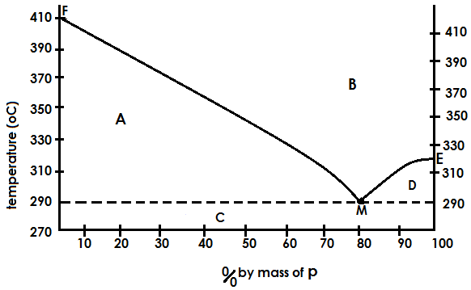

1. Identify the regions A, B, C & D. (02 marks)

A:……………………………………………………………………………………………………………………

B:…………………………………………………………………………………………………………………….

C:…………………………………………………………………………………………………………………….

D:…………………………………………………………………………………………………………………….

1. State what point M represent. (01 mark)

………………………………………………………………………………………………………………………..

1. Using the diagram, estimate the melting point of: (01 mark)

P:…………………………………………………………………………………………………………………….

Q:……………………………………………………………………………………………………………………

1. Describe what would happen if a mixture containing **50%** by mass of P and Q is cooled from **410ᵒC** to **270ᵒC**. (03 marks)

………………………………………………………………………………………………………………………………………………………………………………………………………………………………………………………………………………………………………………………………………………………………………………………………………………………………………………………………………………………………………………………………………………………………………………………………………………………………………………………………………………………………………………………………………………………………………………………………………………………………………………………………………………………………………………………………………………………………………………………………………………………………………………………………………………………………………………………………………………………………………………………………………………………………………………………………………………………………………………………………………………………………………………………………………………………………………………………………………………………………………………………………………………………………………………………………………………………

1. State one each difference and similarity between the substance at point M and a pure compound. (@01 mark)
2. Difference:

……………………………………………………………………………………………………………………………………………………………………………………………………………………………………………………………………………………………………………………………………………………………………………………………………………………………………………………………………………………

1. Similarity:

………………………………………………………………………………………………………………………………………………………………………………………………………………………………………………………………………………………………………………………………………………………………………

1. Define the term enthalpy of solution. (01 mark)

……………………………………………………………………………………………………………………………………………………………………………………………………………………………………………………………………………………………………………………………………………………………………………………………………………………………………………………………………………………………………………………………………………………………………………………………………………………..

1. In an experiment to determine the enthalpy of solution of anhydrous and hydrated copper (II) sulphate salts, **4.0g** of anhydrous salt was added to **50g** of water and temperature of water rose by **8.0ᵒC**.When **4.0g** of the hydrated salt [CuSO4.5H2O] was added to **50g** of water, the temperature of water dropped by **1.3ᵒC**. Calculate the enthalpy of solution in **kJ/mol** of: [Specific heat capacity of solution = **4.2J/g/ᵒC**]
2. Anhydrous copper (II) sulphate. (02½ marks)

………………………………………………………………………………………………………………………………………………………………………………………………………………………………………………………………………………………………………………………………………………………………………………………………………………………………………………………………………………………………………………………………………………………………………………………………………………………………………………………………………………………………………………………………………………………………………………………………………………………………………………………………………………………………………………………………………………………………………………………………………………………………………………………………………………………………………………………………………………………………………………………..

1. Hydrate copper (II) sulphate. (02 marks)

…………………………………………………………………………………………………………………………………………………………………………………………………………………………………………………………………………………………………………………………………………………………………………………………………………………………………………………………………………………………………………………………………………………………………………………………………………………………………………………………………………………………………………………………………………………………………………………………………………………………………………………………………………………………………………………………………………………..

1. Comment on the difference in values of enthalpy of solution calculated in (b) above. (02 marks)

…………………………………………………………………………………………………………………………………………………………………………………………………………………………………………………………………………………………………………………………………………………………………………………………………………………………………………………………………………………………………………………………………………………………………………………………………………………………………………………………………………………………………………………………………………………………………………………………………………………………………

1. Calculate the enthalpy change for the reaction:

CuSO4(aq)  + 5H2O(l) CuSO4.5H2O(l)

………………………………………………………………………………………………………………………………………………………………………………………………………………………………………………………………………………………………………………………………………………………………………………………………………………………………………………………………………………………………………………………………………………………………………………………………………………………………………………………………………………………………………………………………………………………………………………………………………………………………………………………………………………………………………………………………………………………………………………………………………………………………………………………………………………………………………………………

1. Nitrogen and hydrogen react to form ammonia according to equation below: N2(g) + 3H2(g)  2NH3(g) ∆H = -92kJ/mol
2. State the industrial conditions used to obtain a maximum yield of ammonia gas. (01½ marks)

……………………………………………………………………………………………………………………………………………………………………………………………………………………………………………………………………………………………………………………………………………………………………………………………………………………………………………………………………………………………..

1. During the manufacture of nitric acid, ammonia is catalytically oxidized to P which is further oxidized to Q. Q is then reacted with water to produce nitric acid.
2. Name P and Q. (@0½ mark)

P = ……………………………………………………………………………………………………………

Q = ………………………………………………………………………………………………………….

1. Write equations for the formation of: (@01½ marks)

P:

……………………………………………………………………………………………………………………………………………………………………………………………………………………………………………..

Q:

……………………………………………………………………………………………………………………………………………………………………………………………………………………………………………..

Nitric acid:

……………………………………………………………………………………………………………………………………………………………………………………………………………………………………………..

1. Write equations for the reaction of concentrated nitric acid and: (@01½ marks)
2. Carbon.

…………………………………………………………………………………………………………………………………………………………………………………………………………………………………………

1. Copper.

……………………………………………………………………………………………………………………………………………………………………………………………………………………………………

1. Write equations to show how the following compounds can be synthesized.
2. Butanone from calcium carbide. (03½ marks)

………………………………………………………………………………………………………………………………………………………………………………………………………………………………………………………………………………………………………………………………………………………………………………………………………………………………………………………………………………………………………………………………………………………………………………………………………………………………………………………………………………………………………………………………………………………………………………………………………………………………………………………………………

1. Phenylmethanol from benzene. (03½ marks)

………………………………………………………………………………………………………………………………………………………………………………………………………………………………………………………………………………………………………………………………………………………………………………………………………………………………………………………………………………………………………………………………………………………………………………………………………………………………………………………………………………………………………………………………………………………………………………………………………………………………………………………………………

1. But-2-yne from ethyne. (02 marks)

………………………………………………………………………………………………………………………………………………………………………………………………………………………………………………………………………………………………………………………………………………………………………………………………………………………………………………………………………………………………………………………………………………………………………………………………………………………………………………………………………………………………………………………………………………………………………………………………………………………………………………………………………

1. The saturated vapour pressures of liquids **A** & **B** which form an ideal solution at **20ᵒC** are **15kN/m2** and **35kN/m2** respectively. If the total pressure above the solution is **29kN/m2**, Calculate the:
2. Mole fraction of A in the liquid mixture. (02 marks)

…………………………………………………………………………………………………………………………………………………………………………………………………………………………………………………………………………………………………………………………………………………………………………………………………………………………………………………………………………………………………………………………………………………………………………………………………………………………………………………………………………………………………………………………………………………………………………………………………………………………………………………………………………………………………………………………………………………….

1. Composition of the vapour above the liquid mixture of A and B. (02 marks)

……………………………………………………………………………………………………………………………………………………………………………………………………………………………………………………………………………………………………………………………………………………………………………………………………………………………………………………………………………………………………………………………………………………………………………………………

1. The boiling point-composition diagram for a mixture of hydrochloric acid and water is shown below:

(Diagram needed)

1. State how the mixture deviates from Raoult’s law. Give a reason for your answer. (02 marks)

……………………………………………………………………………………………………………………………………………………………………………………………………………………………………………………………………………………………………………………………………………………………………………………………………………………………………………………………………………………………………………………………………………………………………………………………………………………………………………………………………………………………………………………………………………………………………………………………

1. Explain the causes of the deviation you have stated in b (i) above. (03 marks)

…………………………………………………………………………………………………………………………………………………………………………………………………………………………………………………………………………………………………………………………………………………………………………………………………………………………………………………………………………………………………………………………………………………………………………………………………………………………………………………………………………………………………………………………………………………………………………………………..

1. An organic compound, **P** has a molecular formula **C4H9Br**.
2. Name the functional group in organic compound, P. (01 mark)

………………………………………………………………………………………………………………….

1. Write the structural formulae and names of all possible isomers of organic compound, P. (04 marks)

…………………………………………………………………………………………………………………………………………………………………………………………………………………………………………………………………………………………………………………………………………………………………………………………………………………………………………………………………………

1. Identify two isomers in a (ii) that when reacted with hot ethanolic potassium hydroxide solution give the same product. (01 mark)

……………………………………………………………………………………………………………………………………………………………………………………………………………………………………

1. Write the structural formula and name of the product in a (iii). (01 mark)

…………………………………………………………………………………………………………………

1. Outline the mechanism for the reaction between the product in a (iii) and benzene in presence of an acid. (02 marks)

…………………………………………………………………………………………………………………………………………………………………………………………………………………………………………………………………………………………………………………………………………………………………………………………………………………………………………………………………………………………………………………………………………………………………………………………………………………………………………………………………………………………………………………………………………………………………………………………………………………………………………………………………………………………………………………………………………………..

1. The table below shows values for the atomic and ionic radii of the alkali metals.

|  |  |  |
| --- | --- | --- |
| Element | Atomic radius [x 10-10m] | Ionic radius [x 10-10m] |
| Lithium | 1.23 | 0.68 |
| Sodium | 1.57 | 0.97 |
| Potassium | 2.03 | 1.33 |
| Rubidium | 2.16 | 1.47 |
| Caesium | 2.35 | 1.67 |

1. In every case, the radius of an ion is smaller than that of the corresponding atom. Explain. (02 marks)

……………………………………………………………………………………………………………………………………………………………………………………………………………………………………………………………………………………………………………………………………………………………………………………………………………………………………………………………………………………………………………………………………………………………………………………………………………………………………………………………………………………………………………………………………………………………………………………………………………………………………………………………………………………………………………………………………………………………………………………………….

1. Explain the increase in atomic radius along the series lithium to Caesium. (02 marks)

……………………………………………………………………………………………………………………………………………………………………………………………………………………………………………………………………………………………………………………………………………………………………………………………………………………………………………………………………………………………………………………………………………………………………………………………………………………………………………………………………………………………………………………………………………………………………………………………………………………………………………………………………………………………………………………………………………………………………………………………….

1. The ions Na+, Mg2+ & Al3+ have the same electronic configuration, yet they have different ionic radii. Suggest a reason for this. (02 marks)

……………………………………………………………………………………………………………………………………………………………………………………………………………………………………………………………………………………………………………………………………………………………………………………………………………………………………………………………………………………………………………………………………………………………………………………………………………………………………………………………………………………………………………………………………………………………………………………………………………………………………………………………………………………………………………………………………………………………………………………………….

1. Which of the alkali metal ions in the gaseous state is likely to have the highest hydration energy? Give a reason. (03 marks)

……………………………………………………………………………………………………………………………………………………………………………………………………………………………………………………………………………………………………………………………………………………………………………………………………………………………………………………………………………………………………………………………………………………………………………………………………………………………………………………………………………………………………………………………………………………………………………………………………………………………………………………………………………………………………………………………………………………………………………………………….

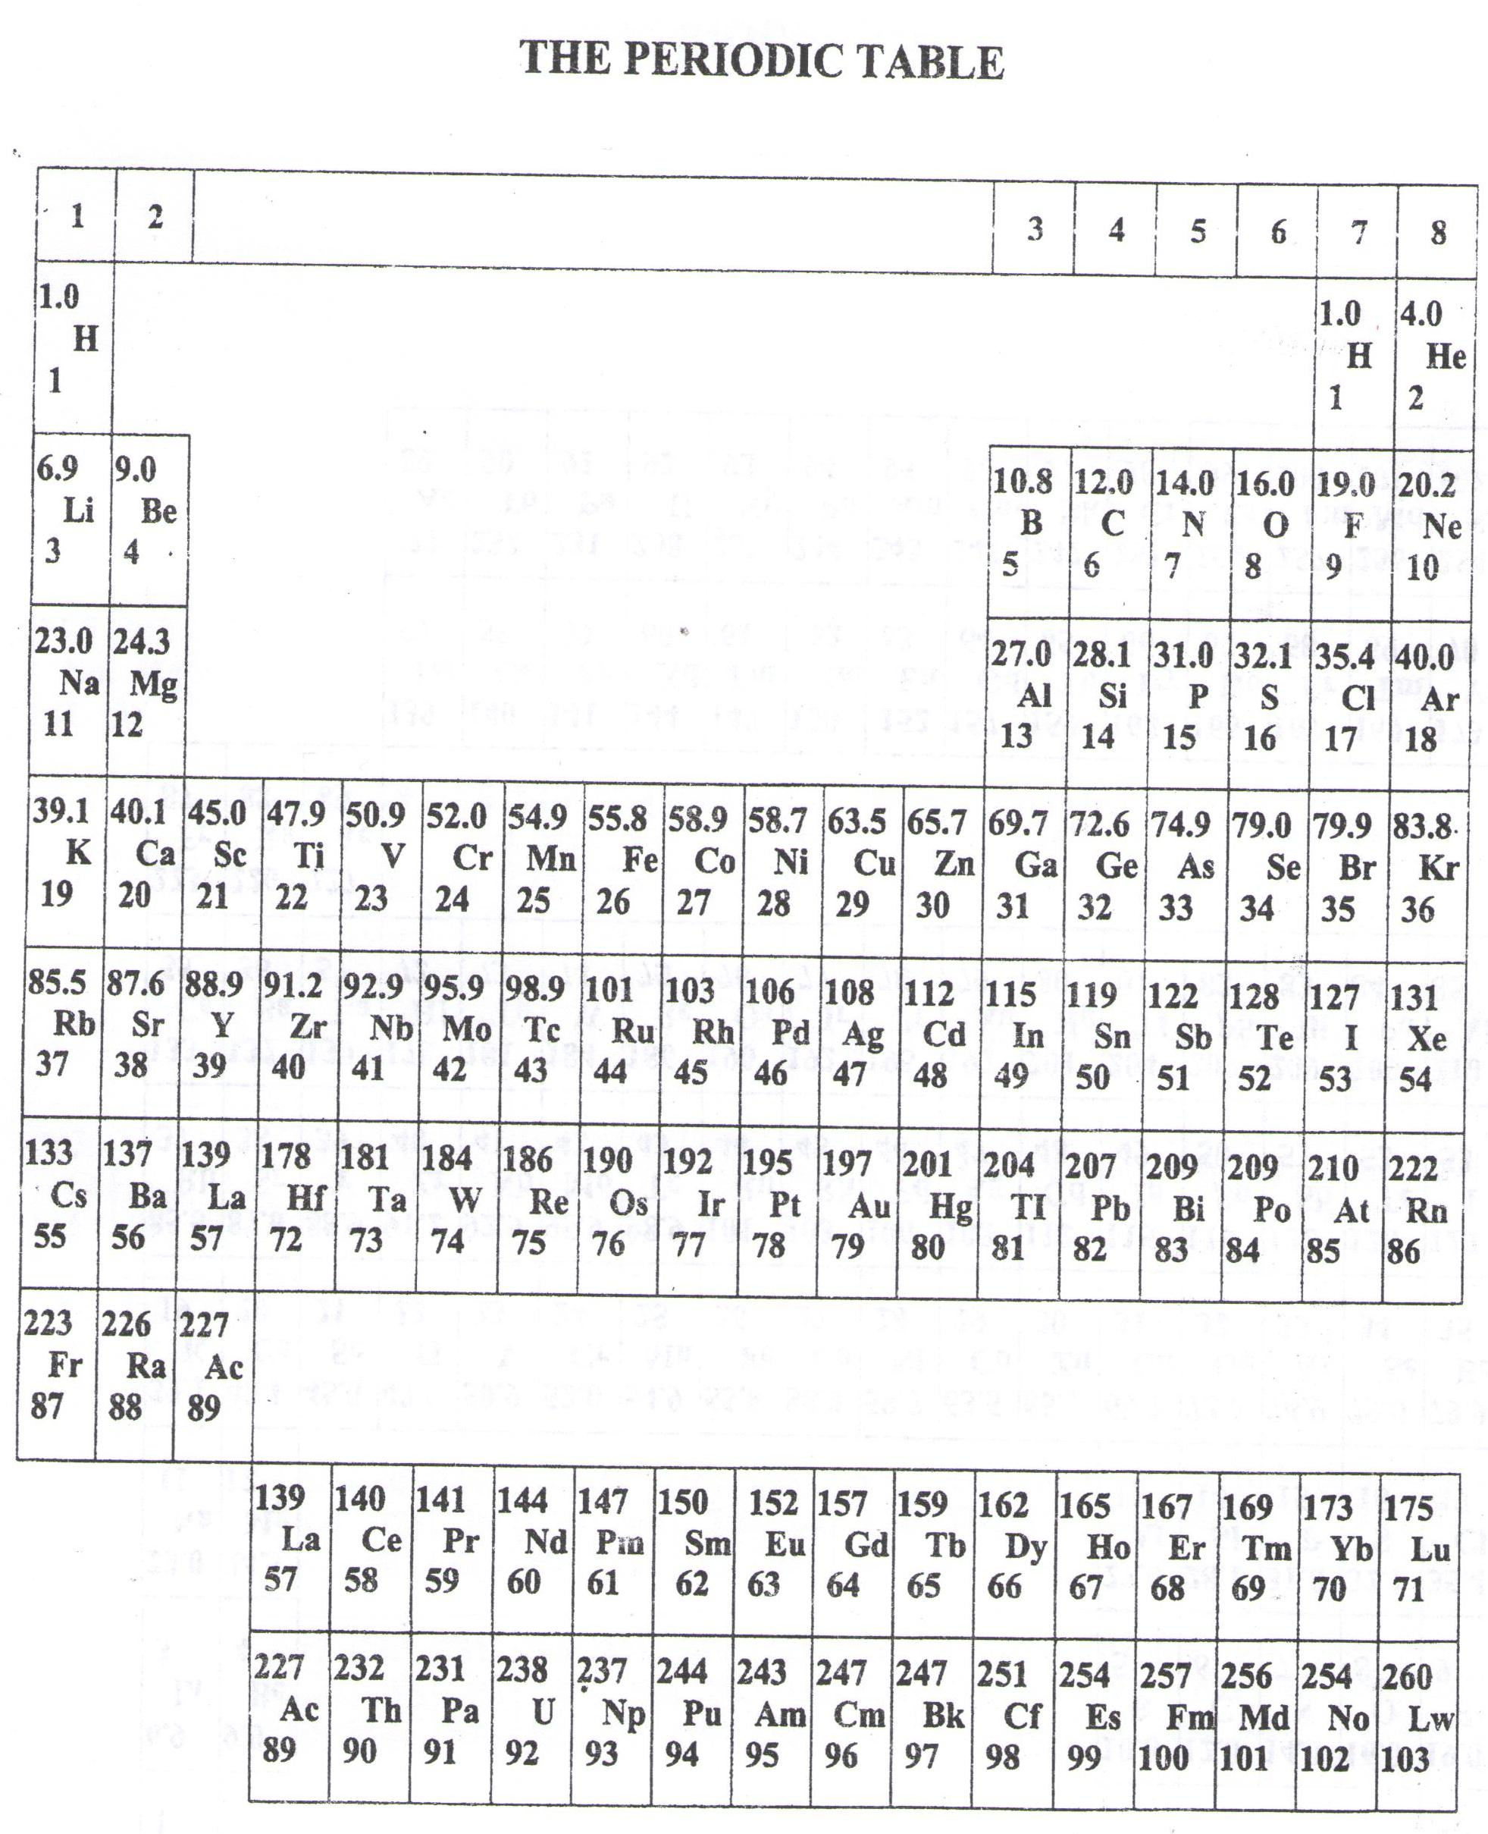

* ===END===

WELCOME TO SENIOR SIX, YEAR 2023

This is the last page of the printed paper, Page 22